**Science Qtech Employee Performance Mapping.**

**Project 1**

DESCRIPTION

Science Qtech is a startup that works in the Data Science field. Science Qtech has worked on fraud detection, market basket, self-driving cars, supply chain, algorithmic early detection of lung cancer, customer sentiment, and the drug discovery field. With the annual appraisal cycle around the corner, the HR department has asked you (Junior Database Administrator) to generate reports on employee details, their performance, and on the project that the employees have undertaken, to analyze the employee database and extract specific data based on different requirements.

**Objective:**

To facilitate a better understanding, managers have provided ratings for each employee which will help the HR department to finalize the employee performance mapping. As a DBA, you should find the maximum salary of the employees and ensure that all jobs are meeting the organization's profile standard. You also need to calculate bonuses to find extra cost for expenses. This will raise the overall performance of the organization by ensuring that all required employees receive training.

**Note:** You must download the dataset from the course resource section in LMS and create a table to perform the above objective.

**Dataset description:**

**emp_record_table:** It contains the information of all the employees.

* EMP_ID – ID of the employee
* FIRST_NAME – First name of the employee
* LAST_NAME – Last name of the employee
* GENDER – Gender of the employee
* ROLE – Post of the employee
* DEPT – Field of the employee
* EXP – Years of experience the employee has
* COUNTRY – Country in which the employee is presently living
* CONTINENT – Continent in which the country is
* SALARY – Salary of the employee
* EMP_RATING – Performance rating of the employee
* MANAGER_ID – The manager under which the employee is assigned
* PROJ_ID – The project on which the employee is working or has worked on

**Proj_table:**It contains information about the projects.

* PROJECT_ID – ID for the project
* PROJ_Name – Name of the project
* DOMAIN – Field of the project
* START_DATE – Day the project began
* CLOSURE_DATE – Day the project was or will be completed
* DEV_QTR – Quarter in which the project was scheduled
* STATUS – Status of the project currently

**Data_science_team:** It contains information about all the employees in the Data Science team.

* EMP_ID – ID of the employee
* FIRST_NAME – First name of the employee
* LAST_NAME – Last name of the employee
* GENDER – Gender of the employee
* ROLE – Post of the employee
* DEPT – Field of the employee
* EXP – Years of experience the employee has
* COUNTRY – Country in which the employee is presently living
* CONTINENT – Continent in which the country is

**The task to be performed:**

1. Create a database named employee, then import **data_science_team.csv** **proj_table.csv** and **emp_record_table.csv** into the **employee**database from

the given resources.

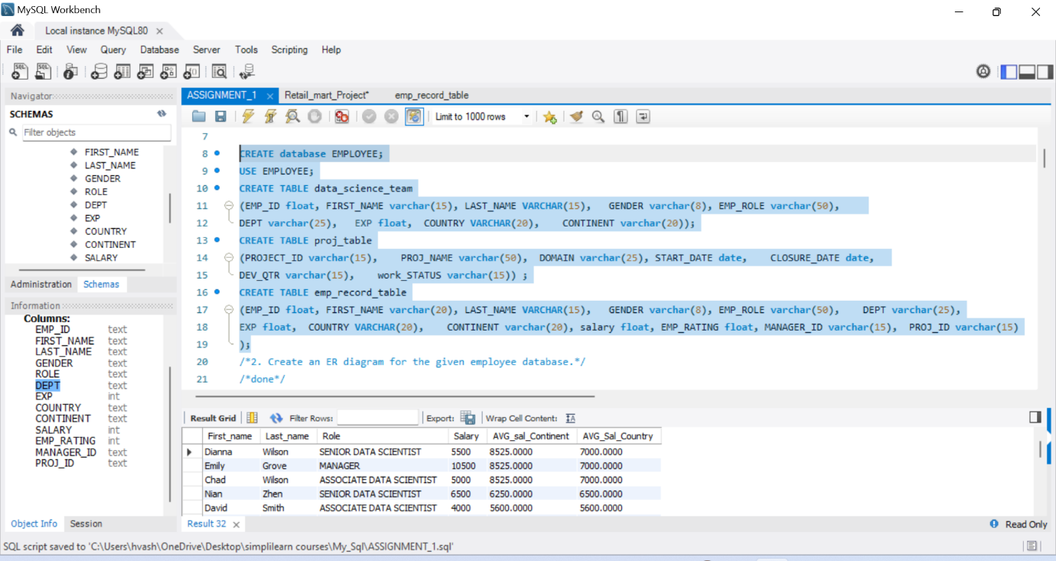

1. Create an ER diagram for the given **employee**database.

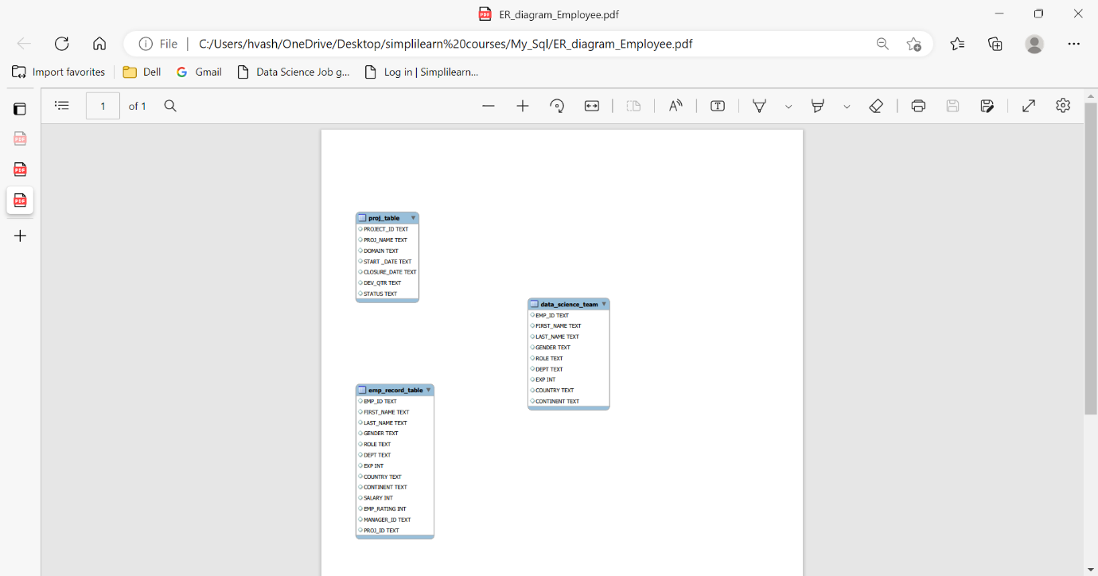

1. Write a query to fetch EMP_ID, FIRST_NAME, LAST_NAME, GENDER, and DEPARTMENT from the employee record table, and make a list of employees and details of their department.

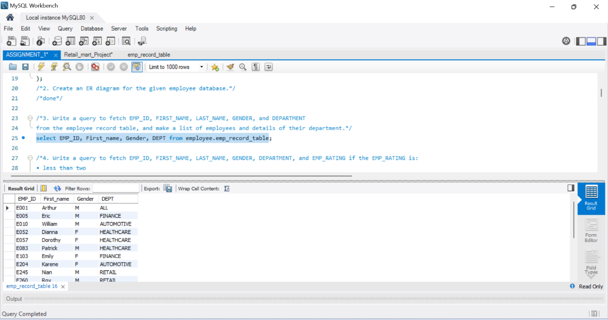

1. Write a query to fetch EMP_ID, FIRST_NAME, LAST_NAME, GENDER, DEPARTMENT, and EMP_RATING if the EMP_RATING is:

• less than two

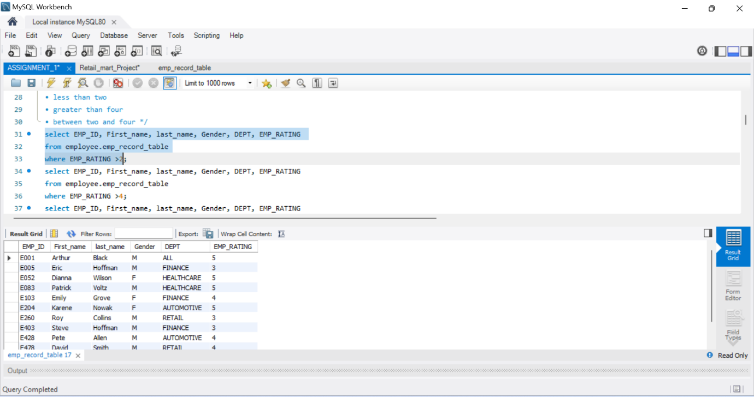

• greater than four

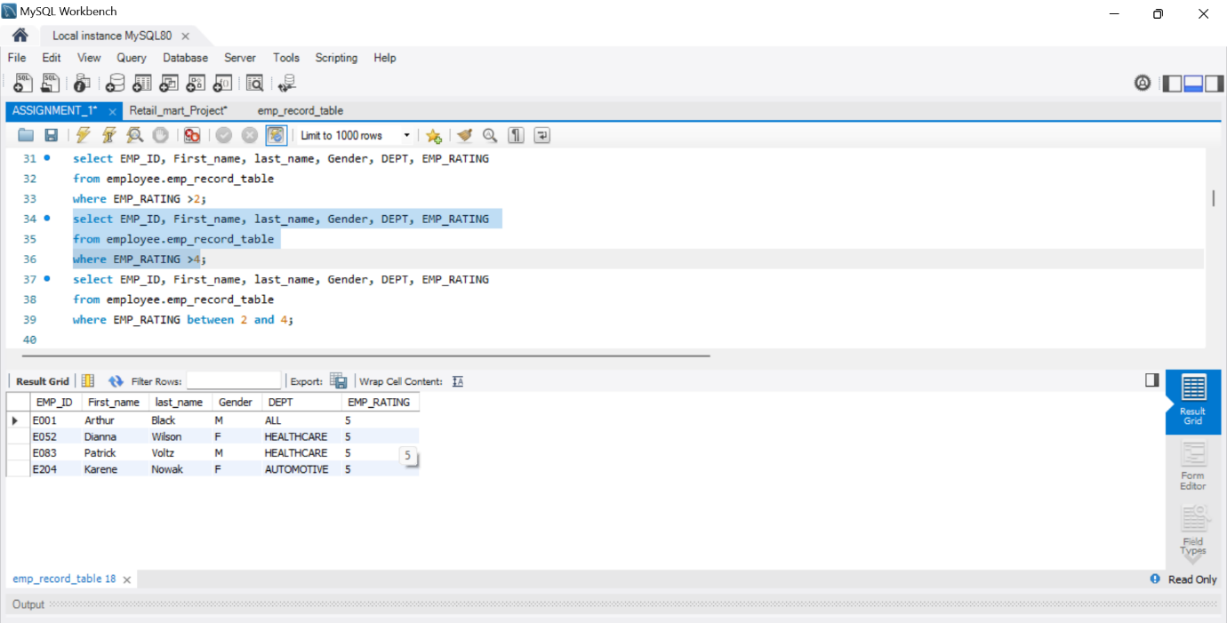

• between two and four

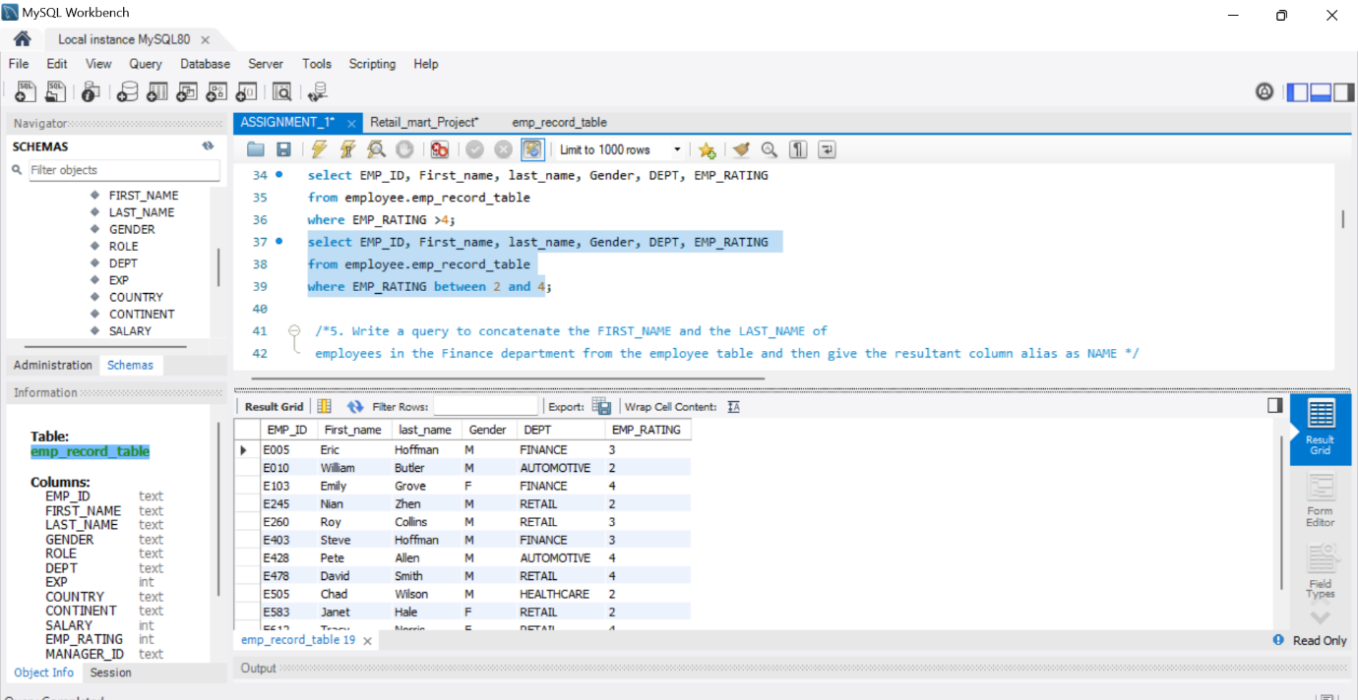

1. Write a query to concatenate the FIRST_NAME and the LAST_NAME of employees in the Finance department from the employee table and then give the resultant column alias as NAME.

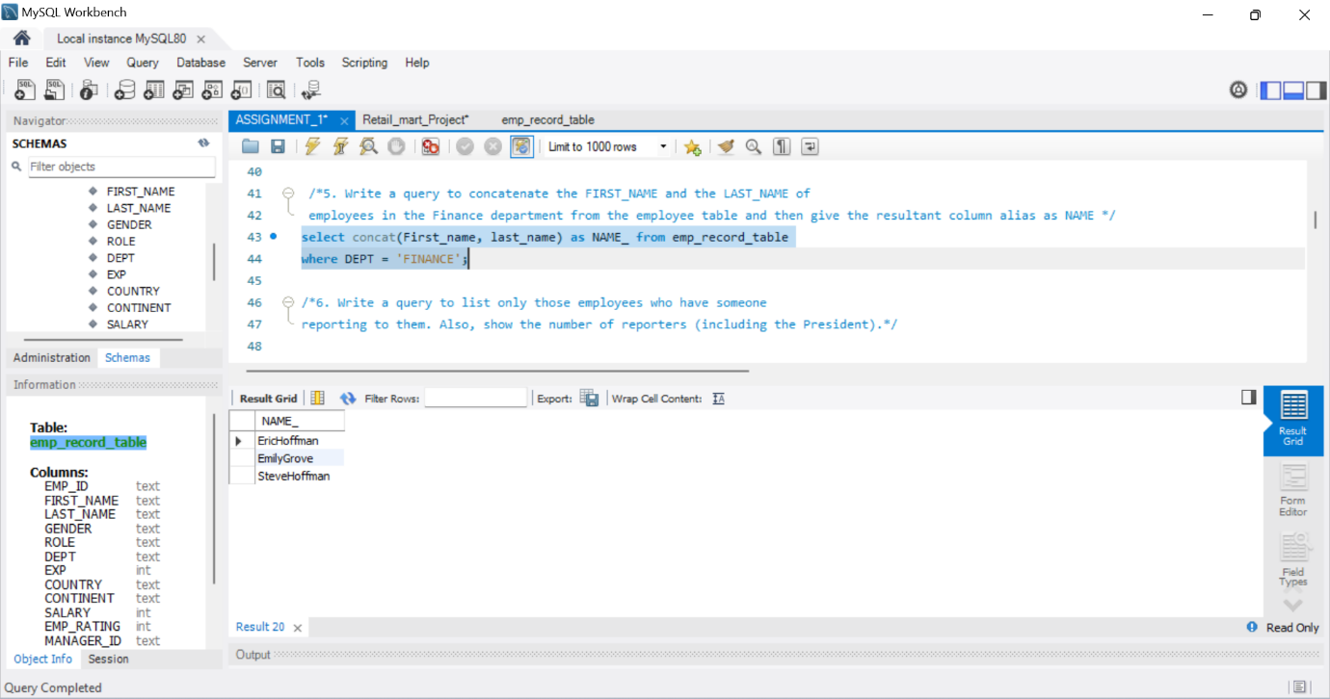

1. Write a query to list only those employees who have someone reporting to them. Also, show the number of reporters (including the President).

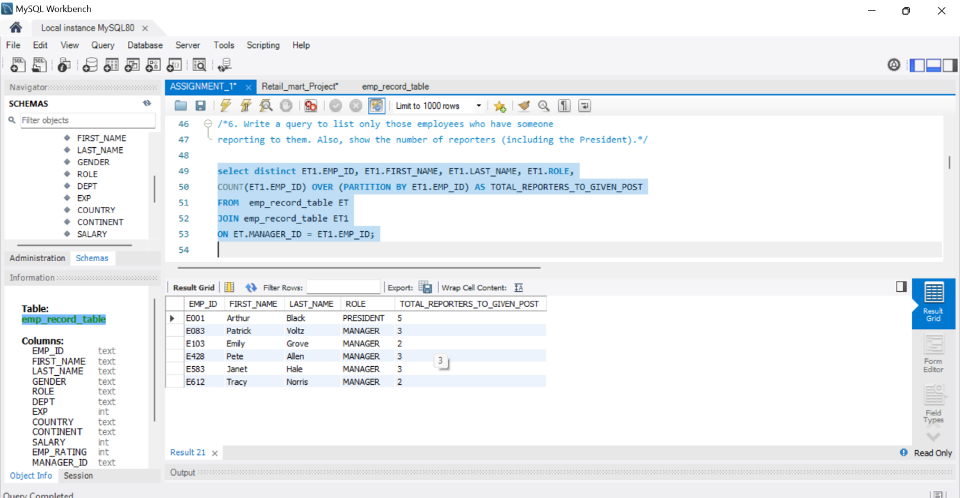

1. Write a query to list down all the employees from the healthcare and finance departments using union. Take data from the employee record table.

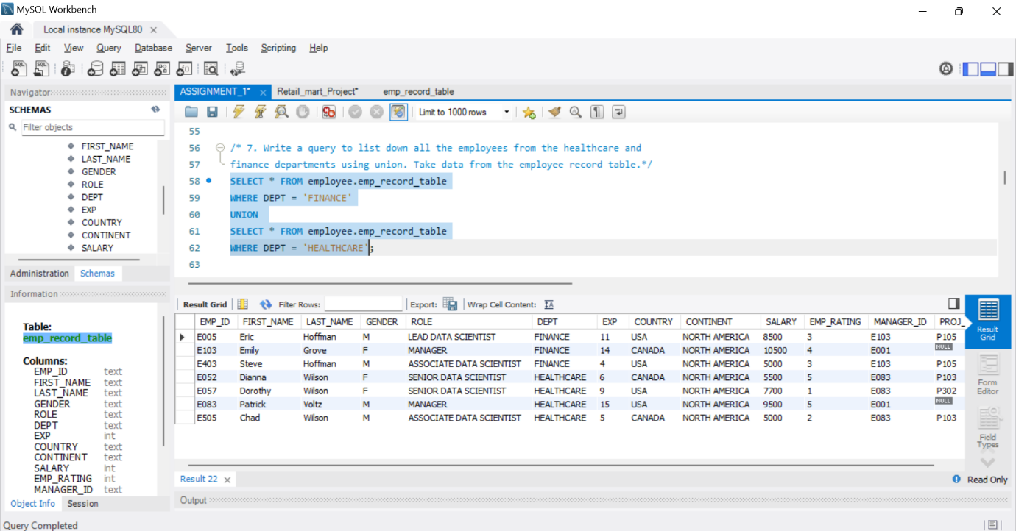

1. Write a query to list down employee details such as EMP_ID, FIRST_NAME, LAST_NAME, ROLE, DEPARTMENT, and EMP_RATING grouped by dept. Also include the respective employee rating along with the max emp rating for the department.

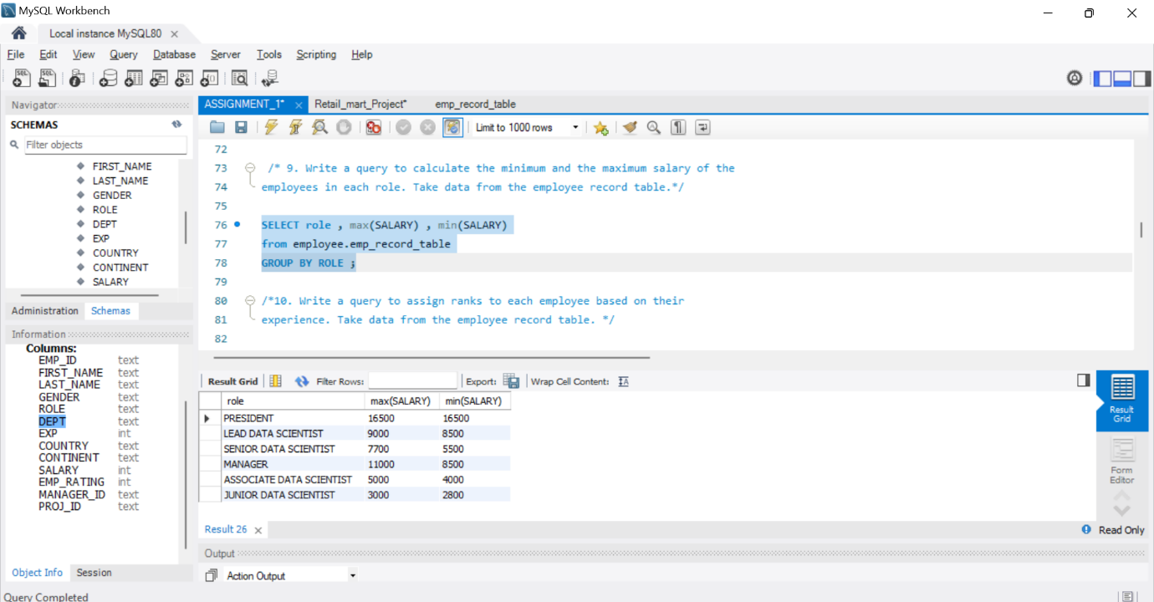

1. Write a query to calculate the minimum and the maximum salary of the employees in each role. Take data from the employee record table.



1. Write a query to assign ranks to each employee based on their experience. Take data from the employee record table.

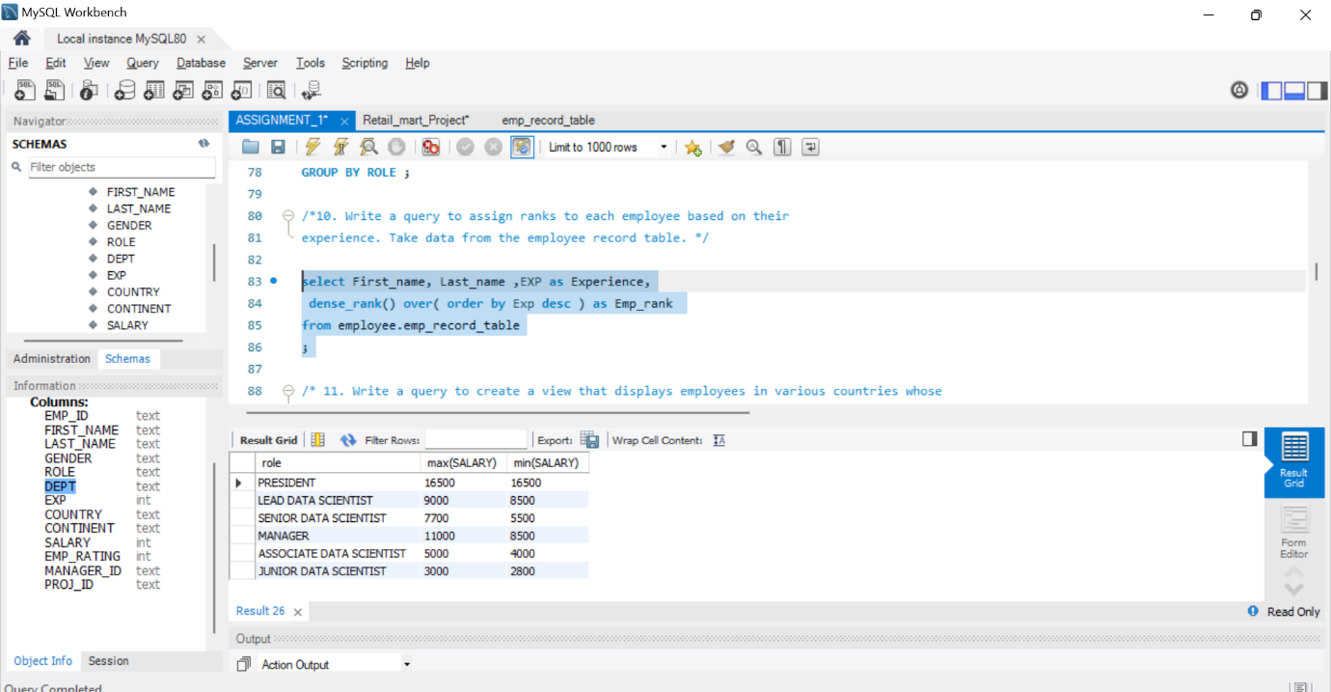

1. Write a query to create a view that displays employees in various countries whose salary is more than six thousand. Take data from the employee record table.

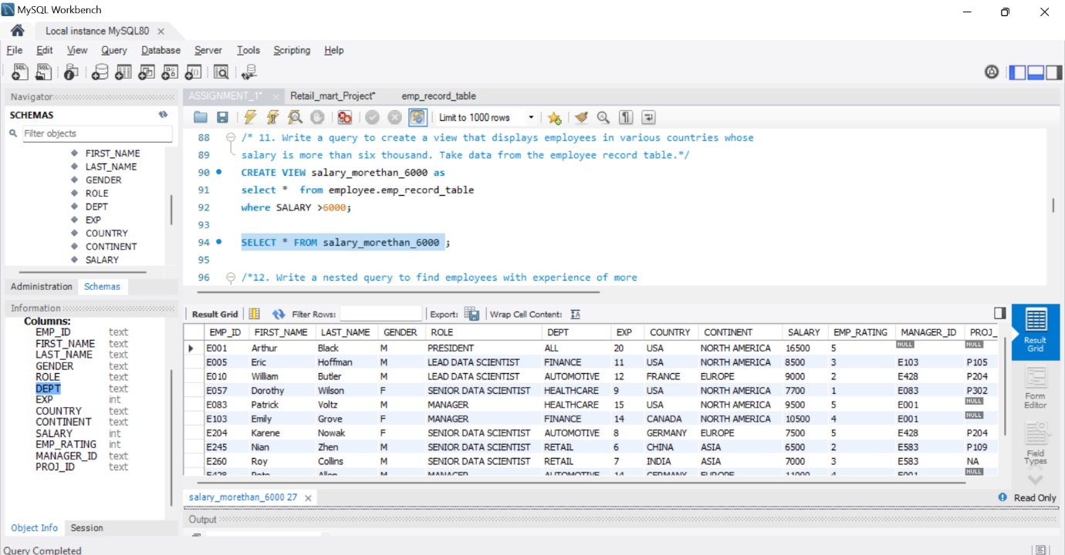

1. Write a nested query to find employees with experience of more than ten years. Take data from the employee record table.

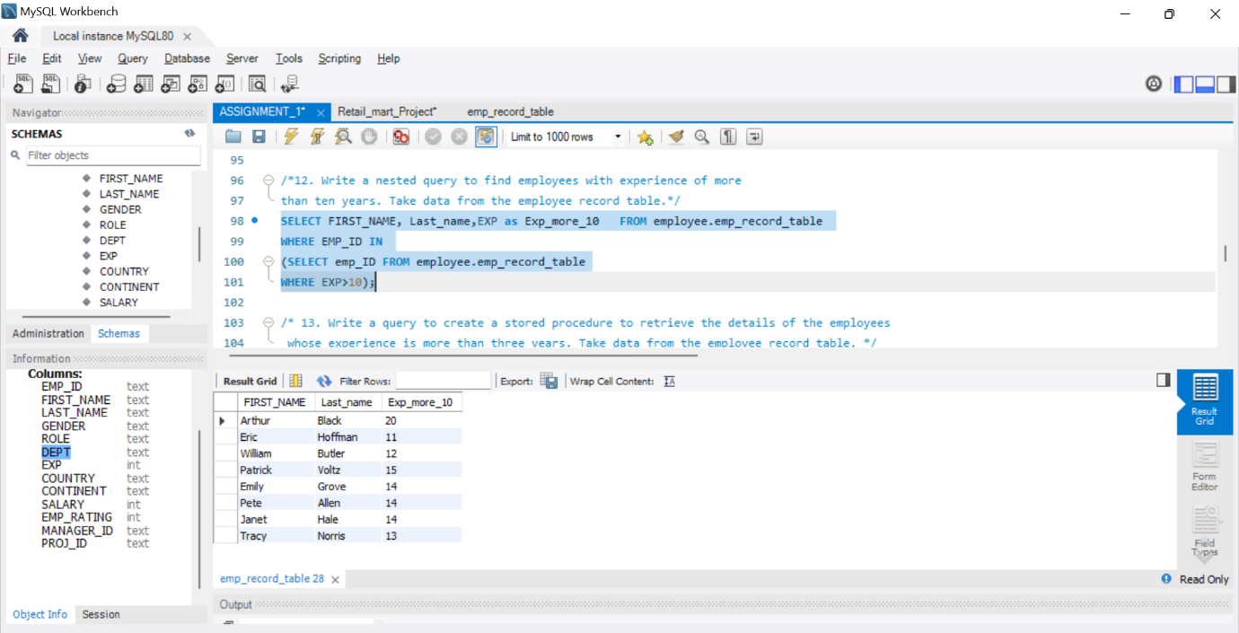

1. Write a query to create a stored procedure to retrieve the details of the employees whose experience is more than three years. Take data from the employee record table.

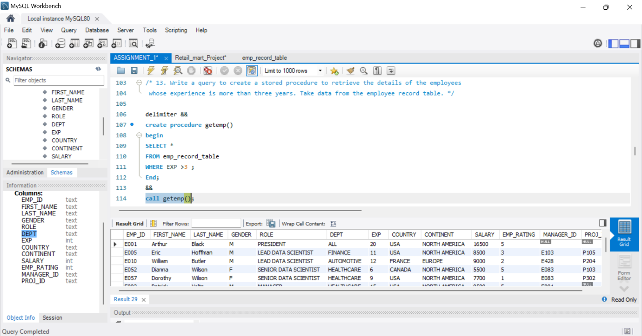

1. Write a query using stored functions in the project table to check whether the job profile assigned to each employee in the data science team matches the organization’s set standard.

The standard is:

For an employee with experience less than or equal to 2 years assign 'JUNIOR DATA SCIENTIST',

For an employee with the experience of 2 to 5 years assign 'ASSOCIATE DATA SCIENTIST',

For an employee with the experience of 5 to 10 years assign 'SENIOR DATA SCIENTIST',

For an employee with the experience of 10 to 12 years assign 'LEAD DATA SCIENTIST'

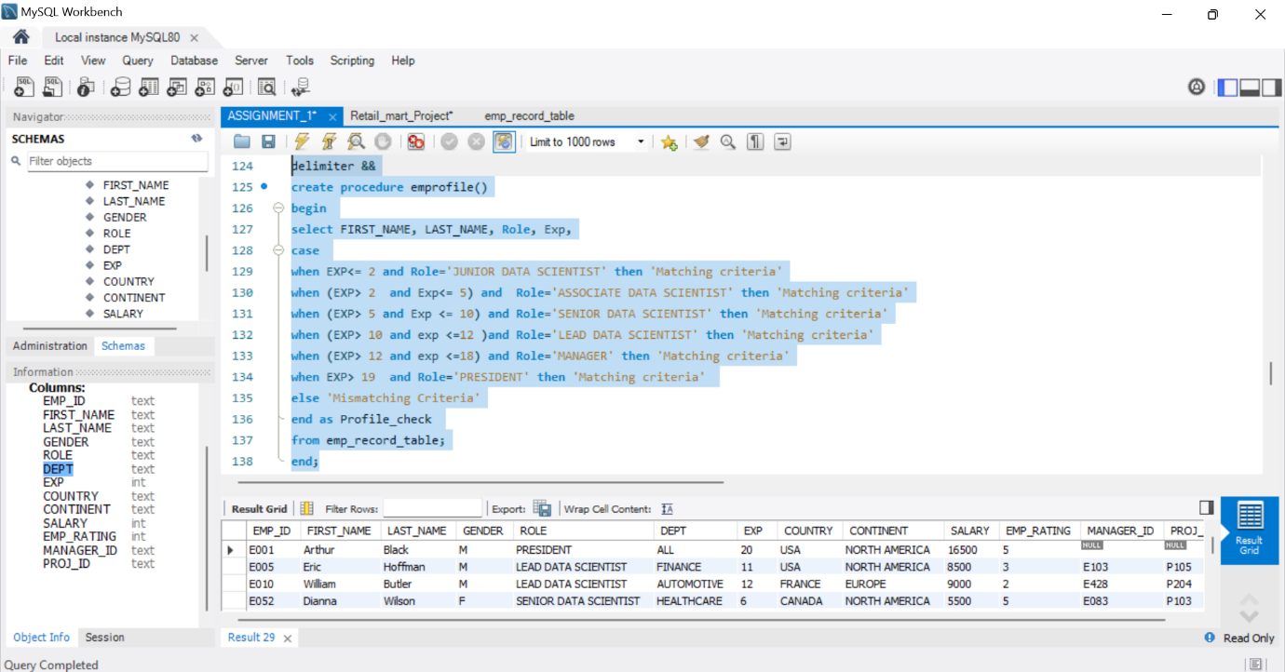

The output

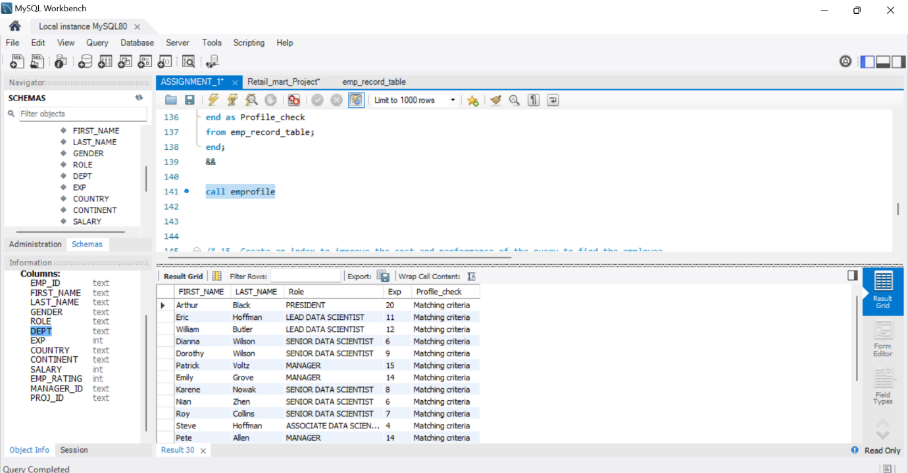

16 Write a query to calculate the bonus for all the employees, based on their ratings and salaries (Use the formula: 5% of salary * employee rating).

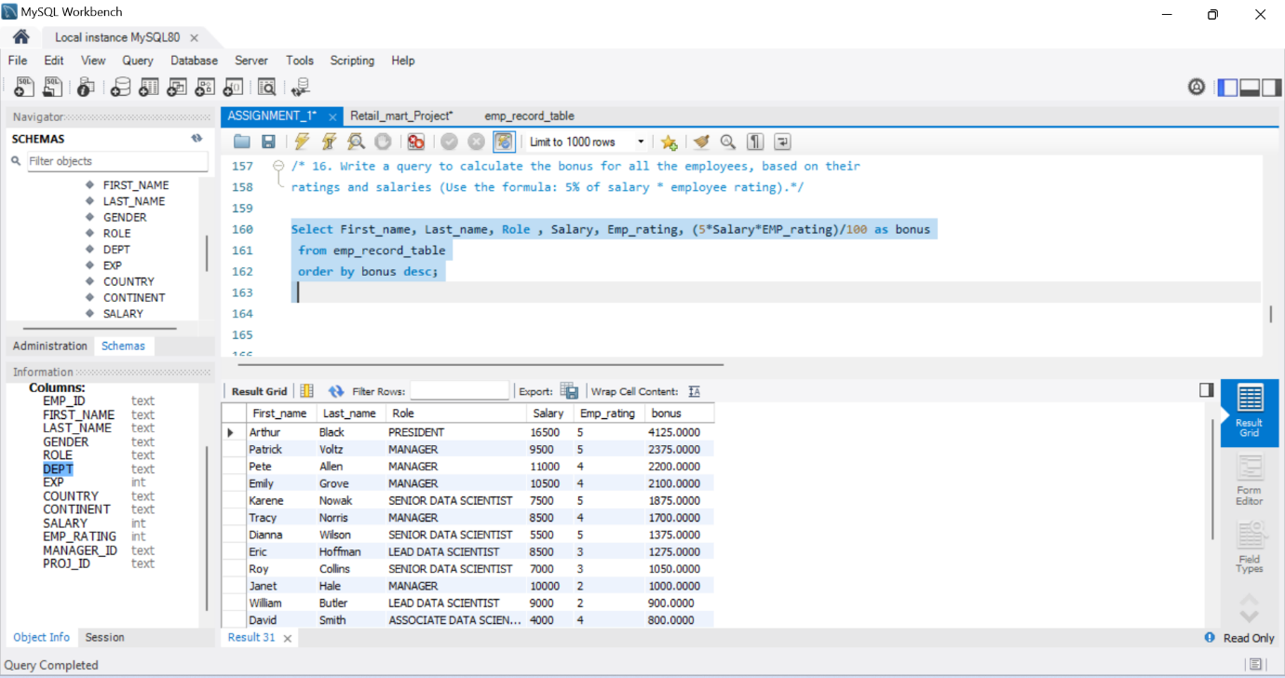

17. Write a query to calculate the average salary distribution based on the continent and country. Take data from the employee record table.

